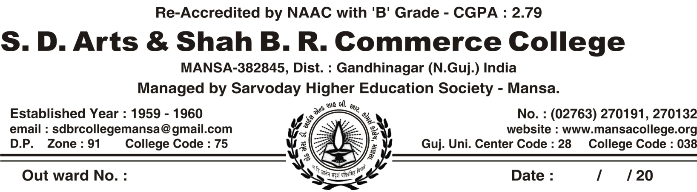

**REGULAR ACTIVITY OF CWDC COMMITTEE, MANSA COLLEGE (2016-17)**

|  |  |  |  |  |
| --- | --- | --- | --- | --- |
| **SR.NO** | **DATE** | **NAME OF ACTIVITY** | **NUMBER OF PARTICIPANTS** | **COLLABORATION WITH** |
|  | 21/7/2016 | Organized Seminar On “**Effect Of Stress On Women”** | 135 | Speaker – Artiben Oza  By CWDC Committee Of Mansa College itself |
|  | 26/7/2016 | Organized **“Mahedi Competition”** | 5 | By CWDC Committee Of Mansa College itself |
|  | 27/7/2016 | Organized **“Hair Style (Kesh Gumfan)**  **Competition”** | 4 | By CWDC Committee Of Mansa College itself |
|  | 27/7/2016 | Organized **“Rangoli Competition”** | 5 | By CWDC Committee Of Mansa College itself |
|  | 1/8/2016 | Organized **“Cooking Competition”** | 1 | By CWDC Committee Of Mansa College itself |
|  | 10/1/2017 | Sarjanatmak Abhivyaki Dhara & Rang Kaushlya Dhara  **Organized Inter College Competition**  **Subjects** :  (1) Poster Making  (2) Story Writing  (3) Poetry Writing – On  Female Subject  (4) Essay Writing | 19 | By CWDC Committee Of Mansa College itself |
|  | 17/2/2017 | Organized Filed Visit At Various Places Like Bal Surksha Vikash Gruh Paldi Ahmedabad, Tri Mandir ,Step Well, Bahera Munga School In Gandhinagar, Andhjan Mandal Ahmedabad Under CWDC Committee & Psychology Department | 35 | CWDC Committee & Psychology Department |

Organized Seminar on “**Effect Of Stress On Women”**

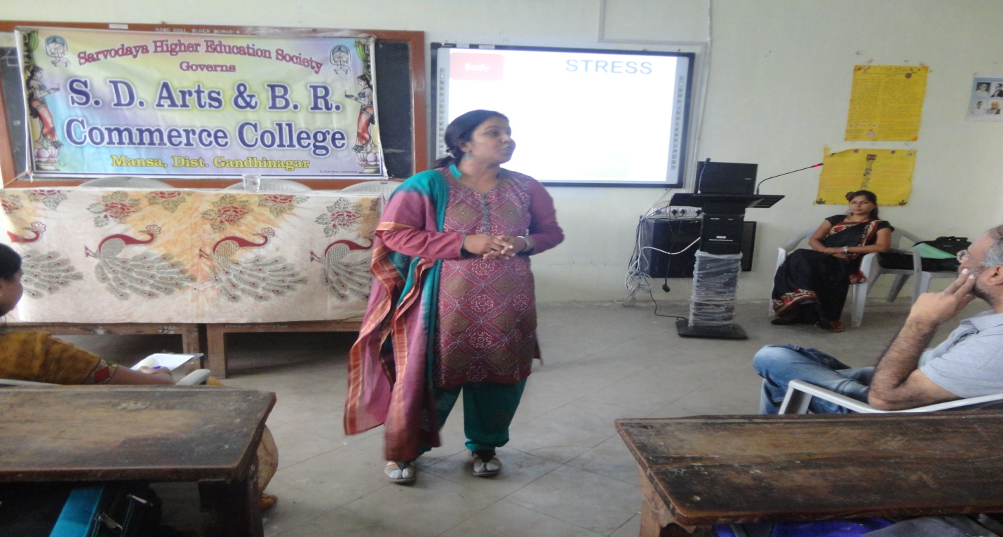

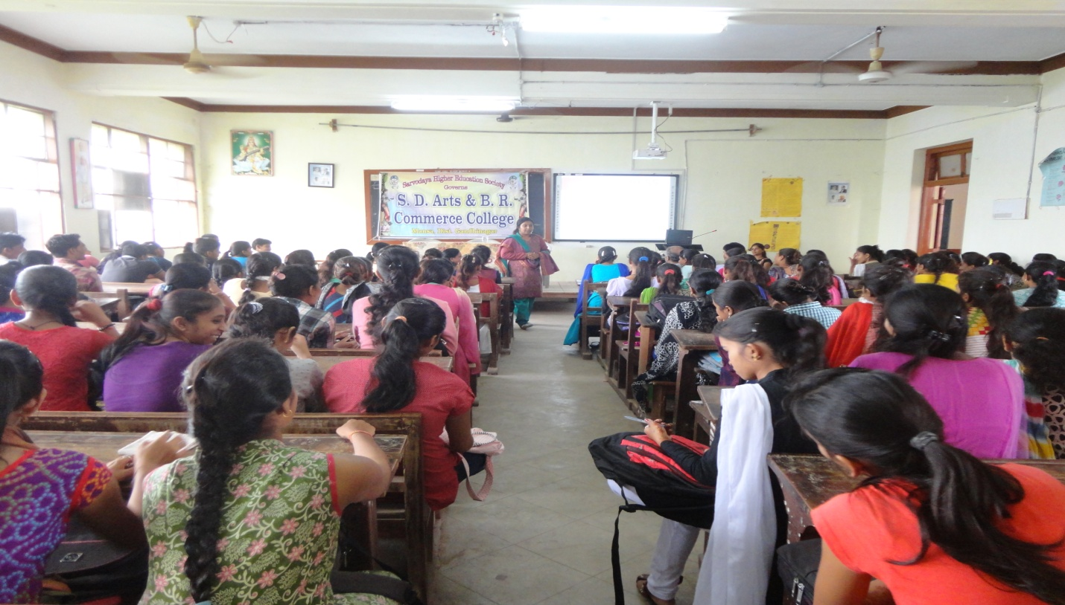

Organized **“Mahedi Competition”**

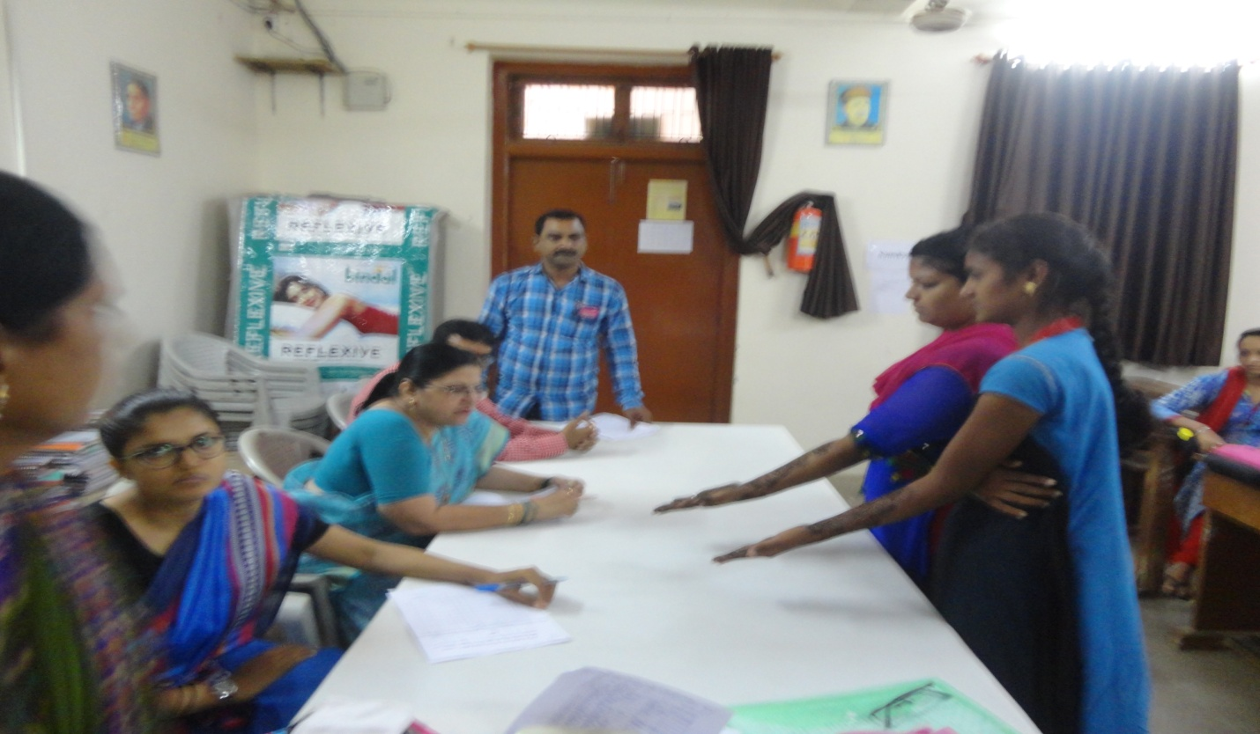

Organized **“Hair Style (Kesh Gumfan) Competition”**

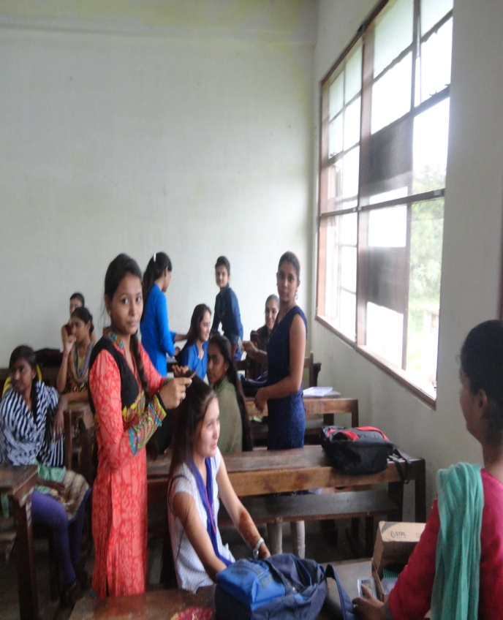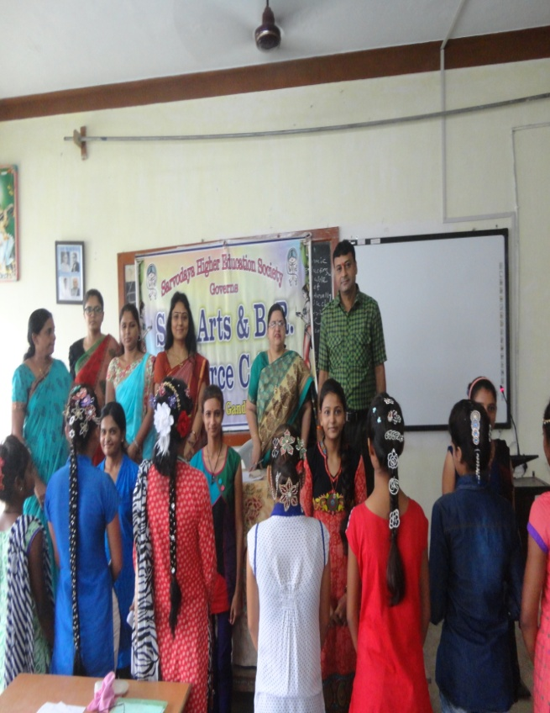

**Organized “Rangoli Competition”**

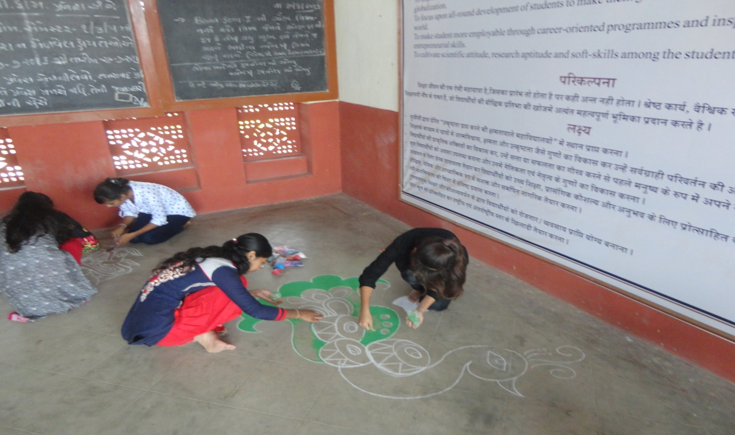

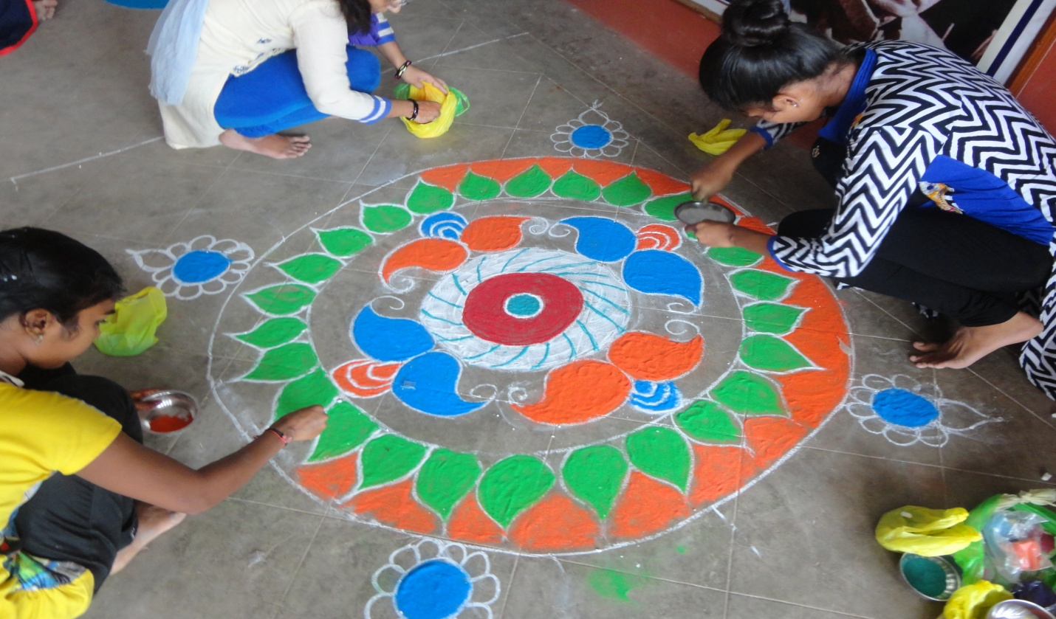

**Organized Filed Visit**

